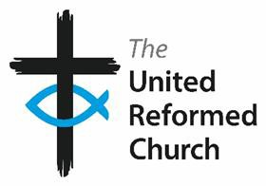

Addressee Name

Dear [name]

## **Committee Membership – End of Term**

Thank you for your service on the XXXX Committee. Your time on this committee and contribution to the work of the United Reformed Church is much appreciated.

During the course of your time on the Committee, you will have received papers and emails containing personal and confidential information. In order to meet the requirements of data protection legislation, you are asked to return to us all such materials or declare that you have securely destroyed them.

I therefore ask you to complete the declaration below.

Thank you once again for your willingness to support the work of the United Reformed Church.

Yours sincerely

On behalf of the Nominations Committee/ Committee Secretary

**Declaration**

I confirm that I have securely destroyed all papers and emails containing personal and/or confidential information, which I received or generated as part of my service between [date] and [date] on the XXXXX Committee. *(delete as applicable)*

OR

I return herewith all papers containing personal and/or confidential information, which I received or generated as part of my service between [date] and [date] on the XXXXX Committee. All emails have been deleted. *(delete as applicable)*

|  |  |  |  |
| --- | --- | --- | --- |
| Signature |  | Date |  |