Acknowledgments

Unless otherwise stated material is © The United Reformed Church.

English translations of the ‘*Nunc Dimittis*’, ‘*Kyrie*’, ‘Gloria in Excelsis’, ‘*Sanctus*’, ‘*Benedictus*’, ‘*Agnus Dei*’ and ‘Lord’s Prayer’ (adapted) © English Language Liturgical Consultation, and used by permission.

Biblical quotations are from the New Revised Standard Edition of the Bible © 1989 The Division of Christian Education of the National Council of Churches in the USA. Used by permission. All rights reserved.

Where biblical texts are given in a form other than that of the NRSV, they have

been compiled from different versions by the editors for reasons of liturgical use.

The Revised Common Lectionary is used by permission of the Consultation on Common Texts.

The United Reformed Church would be pleased to be notified about material which is used here but not acknowledged, and will rectify such omissions in future printings.

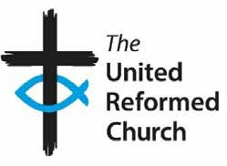

**252** Worship from the URC additional resources